
lAB TASK
SOURCE CODE

LAIBA MUDASSAR
SP26-BCS-021
PROGRAMMING FUNDAMENTALS
LAB TASK 1 GRADE CACULATOR
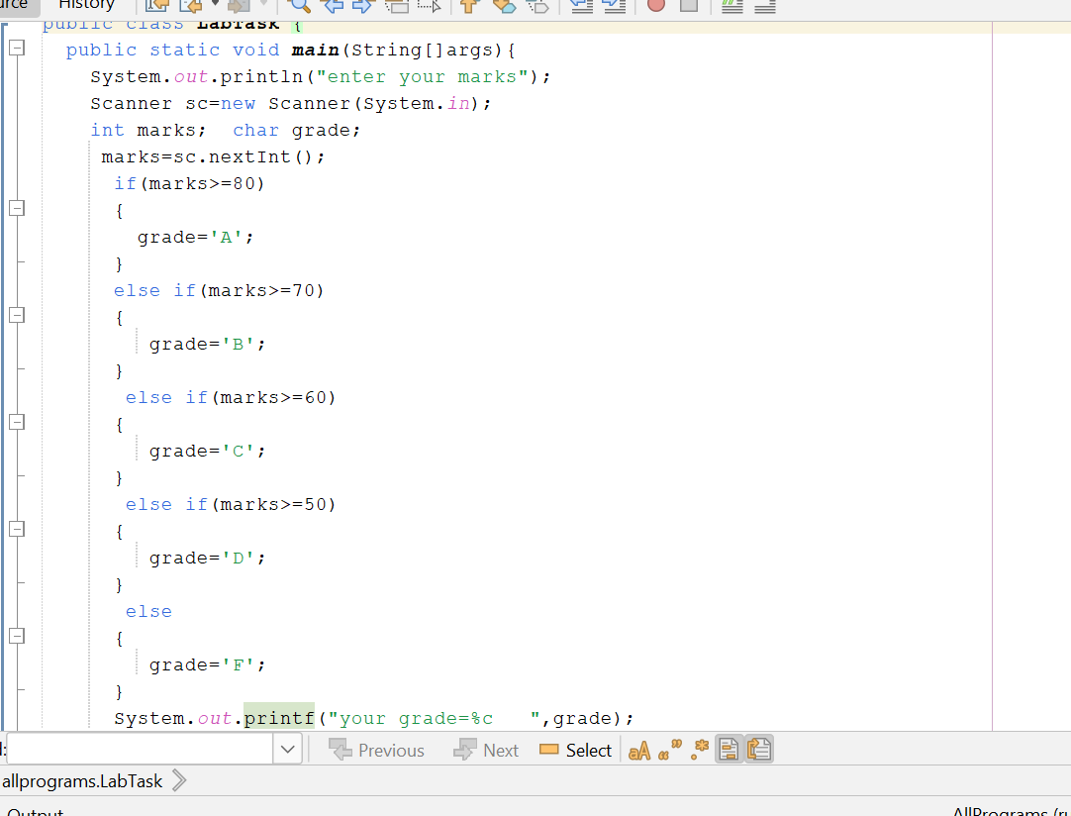
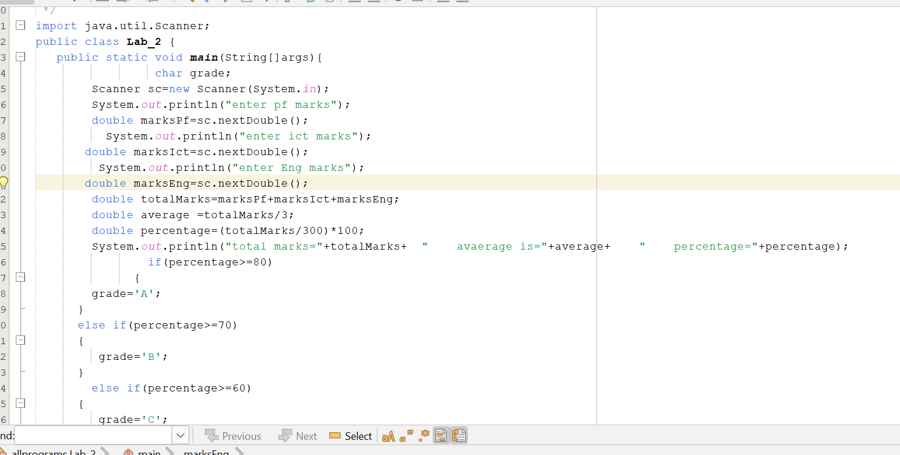
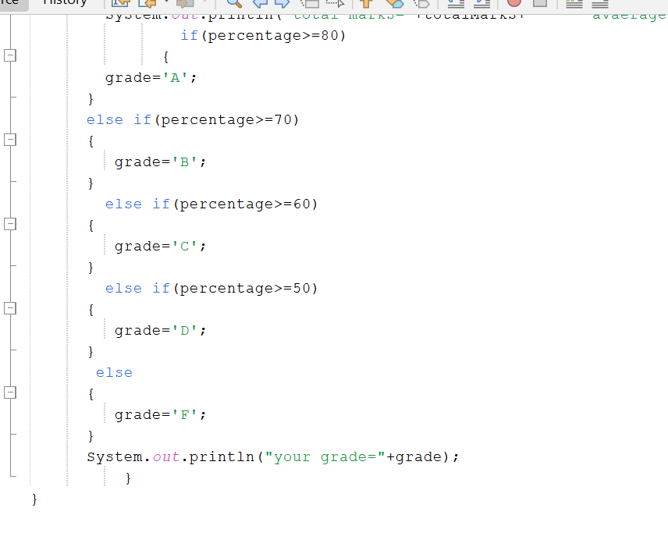
LAB TASK 2
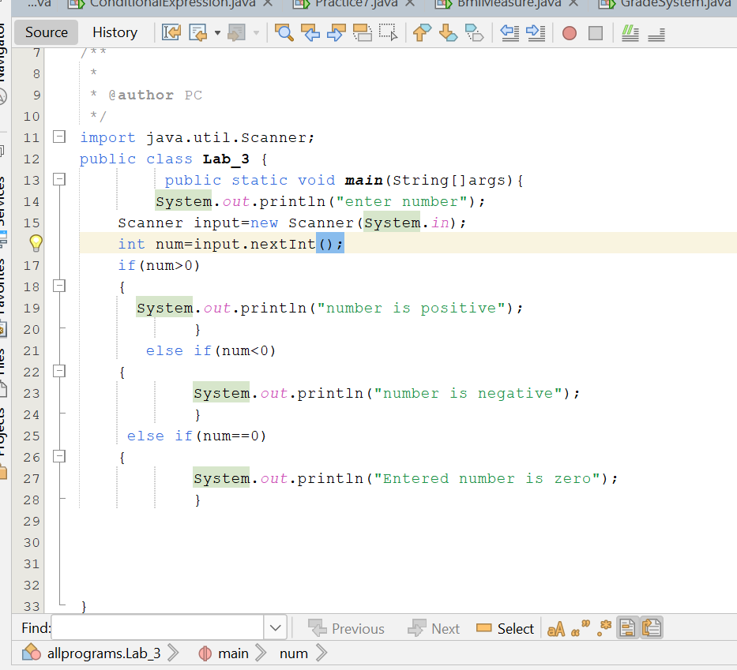
LAB TASK 3

